Experiment Number : 07 Date:

METHOD OVERLOADING AND METHOD OVERRIDING
Aim:
To understand and implement method overloading and method overriding.
PRE LAB EXERCISE
QUESTIONS
- What is method overloading?
Method overloading is a feature where multiple methods have the same name but different parameter lists (different type, number, or order of parameters) in the same class.
Example:
int add(int a, int b) {
return a + b;
}

int add(int a, int b, int c) {
return a + b + c;
}

- What is method overriding?
Method overriding occurs when a subclass provides its own implementation of a method that is already defined in the parent class, using the same method name and parameters.
Example:
class Parent {
void show() {
System.out.println("Parent class");
}
}

class Child extends Parent {
void show() {
System.out.println("Child class");
}
}
- Difference between overloading and overriding.
Method Overloading | Method Overriding
Same method name, different parameters | Same method name, same parameters
Happens in the same class | Happens in different classes
Compile-time polymorphism | Runtime polymorphism
No inheritance required | Inheritance required
Return type can be different | Return type must be same or covariant

IN LAB EXERCISE
Objective:
To demonstrate compile-time and runtime polymorphism.
PROGRAMS:
1.Student Result System (Method Overriding)
Description:
- Base class Student has method displayResult().
- Subclasses UGStudent and PGStudent override the method to show different grading systems.

Code :
import java.util.Scanner;

// Base class
class Student {
String name;

void displayResult() {
System.out.println("Student Result");
}
}

// UG Student subclass
class UGStudent extends Student {
int marks;

UGStudent(String n, int m) {
name = n;
marks = m;
}

@Override
void displayResult() {
double percentage = (marks / 100.0) * 100;
System.out.println("UG Student: " + name);
System.out.println("Marks: " + marks);
System.out.println("Percentage: " + percentage + "%");
}
}

// PG Student subclass
class PGStudent extends Student {
double gpa;

PGStudent(String n, double g) {
name = n;
gpa = g;
}

@Override
void displayResult() {
System.out.println("PG Student: " + name);
System.out.println("GPA: " + gpa + " / 10");
}
}

// Main class
public class Main {
public static void main(String[] args) {
Scanner sc = new Scanner(System.in);

// Input for UG student
System.out.print("Enter UG Student Name: ");
String ugName = sc.nextLine();
System.out.print("Enter UG Student Marks (out of 100): ");
int ugMarks = sc.nextInt();
sc.nextLine(); // consume newline

// Input for PG student
System.out.print("Enter PG Student Name: ");
String pgName = sc.nextLine();
System.out.print("Enter PG Student GPA (0-10): ");
double pgGpa = sc.nextDouble();

// Create objects
Student s1 = new UGStudent(ugName, ugMarks);
Student s2 = new PGStudent(pgName, pgGpa);

System.out.println("\n--- Student Results ---");
s1.displayResult();
System.out.println();
s2.displayResult();

sc.close();
}
}
OUTPUT:

Sample Input:
Enter UG Student Name: Ram
Enter UG Student Marks (out of 100): 85
Enter PG Student Name: Ravi
Enter PG Student GPA (0-10): 9.2
Output:
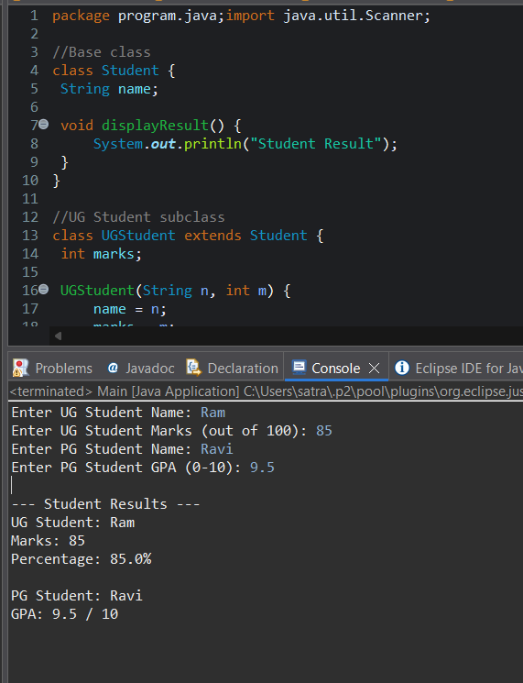
--- Student Results ---
UG Student: Ram
Marks: 85
Percentage: 85.0%
PG Student: Ravi
GPA: 9.2 / 10

2. Calculator Program (Method Overloading)
Description:
Create a Calculator class with multiple add() methods to calculate:
- Addition of 2 integers
- Addition of 3 integers
- Addition of 2 double numbers
Code:
import java.util.Scanner;
class Calculator {
int add(int a, int b) {
return a + b;
}

int add(int a, int b, int c) {
return a + b + c;
}

double add(double a, double b) {
return a + b;
}
}
public class Main {
public static void main(String[] args) {
Scanner sc = new Scanner(System.in);
Calculator calc = new Calculator();

System.out.print("Enter two integers: ");
int x = sc.nextInt();
int y = sc.nextInt();
System.out.println("Sum of two integers: " + calc.add(x, y));

System.out.print("Enter three integers: ");
int p = sc.nextInt();
int q = sc.nextInt();
int r = sc.nextInt();
System.out.println("Sum of three integers: " + calc.add(p, q, r));

System.out.print("Enter two decimal numbers: ");
double a = sc.nextDouble();
double b = sc.nextDouble();
System.out.println("Sum of two doubles: " + calc.add(a, b));

sc.close();
}
}
Output:
Sample Input:
Enter two integers: 10 20
Enter three integers: 5 10 15
Enter two decimal numbers: 2.5 3.5

Output:
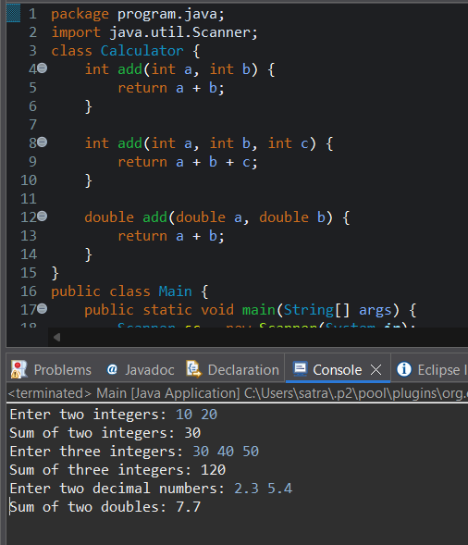
Sum of two integers: 30
Sum of three integers: 30
Sum of two doubles: 6.0

POST LAB EXERCISE
- Is return type important in method overloading and method overriding?
Method overloading: Return type alone is not important; methods must differ in parameter list.
Method overriding: Return type must be same or covariant (compatible with parent method).

- Can you overload a method by changing only the return type?
No.
Changing only the return type causes a compile-time error because the method signature remains the same.

- Can static methods be overridden? Can they be overloaded?
Static methods cannot be overridden because they belong to the class, not the object.
Static methods can be overloaded by changing the parameter list.

- Can a method be overridden if the parameter list is different?
No.
For overriding, the method name and parameter list must be exactly the same.
If parameters differ, it becomes method overloading, not overriding.
Result:
Thus the method overloading and overriding concepts were implemented and executed successfully.
ASSESSMENT

Description | Max Marks | Marks Awarded
Pre Lab Exercise | 5
In Lab Exercise | 10
Post Lab Exercise | 5
Viva | 10
Total | 30
Faculty Signature

